

Active Learning Project Exploring the Functionalities, Data and Interfaces of a Modern Online Advertising System
Authored by: Grace Chuan, Emily Jiang, and Bhavik Nagda

Associated MIT SERC Case Study:

Identity, Advertising, and Algorithmic Targeting: Or How (Not) to Target Your “Ideal User”

Kant, T. (2021). Identity, Advertising, and Algorithmic Targeting: Or How (Not) to Target Your “Ideal User.” MIT Case Studies in Social and Ethical Responsibilities of Computing, (Summer 2021). https://doi.org/10.21428/2c646de5.929a7db6

Overview:

The last two decades of digital transformation have revealed our broad societal dependence upon data-rich, “Big Tech” firms. From seemingly humble beginnings to present-day backlash and congressional scrutiny, these companies have weathered good and bad times alike. Facebook is, perhaps, the epitome of this Big Tech archetype. The company capitalizes on its users' time, selling advertising space for its Facebook, WhatsApp, and Instagram platforms. As you’ll notice in the following lab, Facebook is relevant in digital advertising for many types of organizations, including small and medium-sized businesses, Fortune 500s, restaurants, and political campaigns.

As we explore the ethical implications of digital advertising, it's particularly helpful to concretely identify the functionalities, data, and interfaces driving ad systems in the modern era. The following lab focuses on Facebook’s Ads Manager with this in mind.

Imagine, for the next hour, that you’re the owner of Beurre Bakery, a bakery and cafe chain with multiple locations throughout Boston and Cambridge. As owner, you’ve been reticent to transform the local, grassroots marketing that has been so effective over the past decade; however, competition has been intensifying, so you’ve decided to explore Facebook’s Ads offering. Explore the following lab, revamping Beurre’s digital marketing with an eye toward the societal and ethical implications of the data platform.

Step 1: Enter Facebook Business’s Ads Manager with the following login information.
We can use one account for several different pages/businesses.
- Username: XYZ
- Password: ABC

Step 2: Click on the “Ads” tab in the left-hand bar to reach the Ad Center.
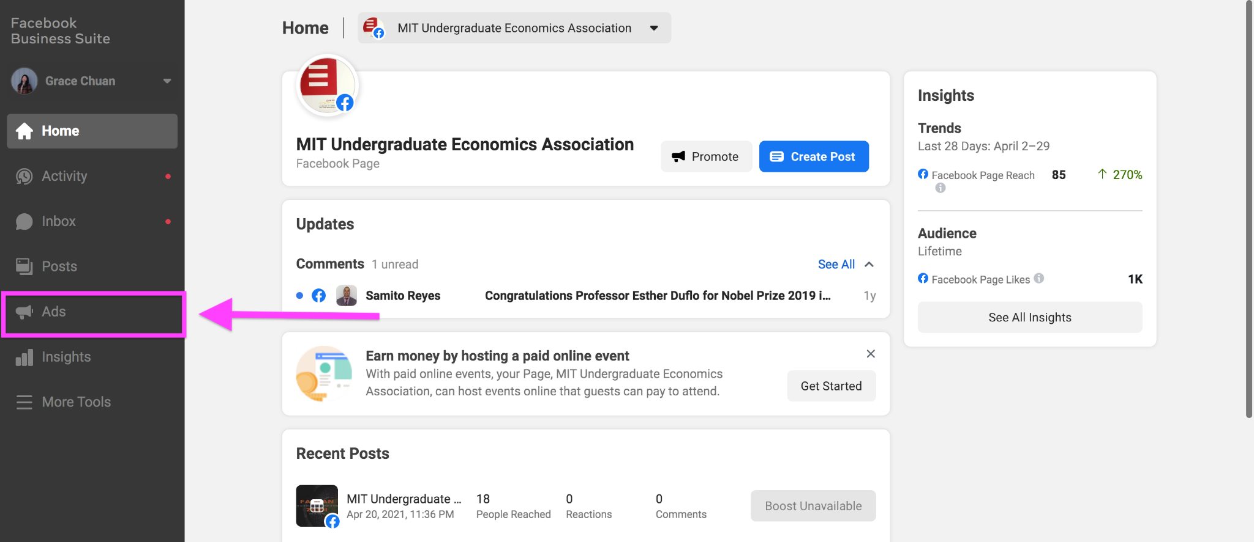
Step 3: Click “Ads Manager.”
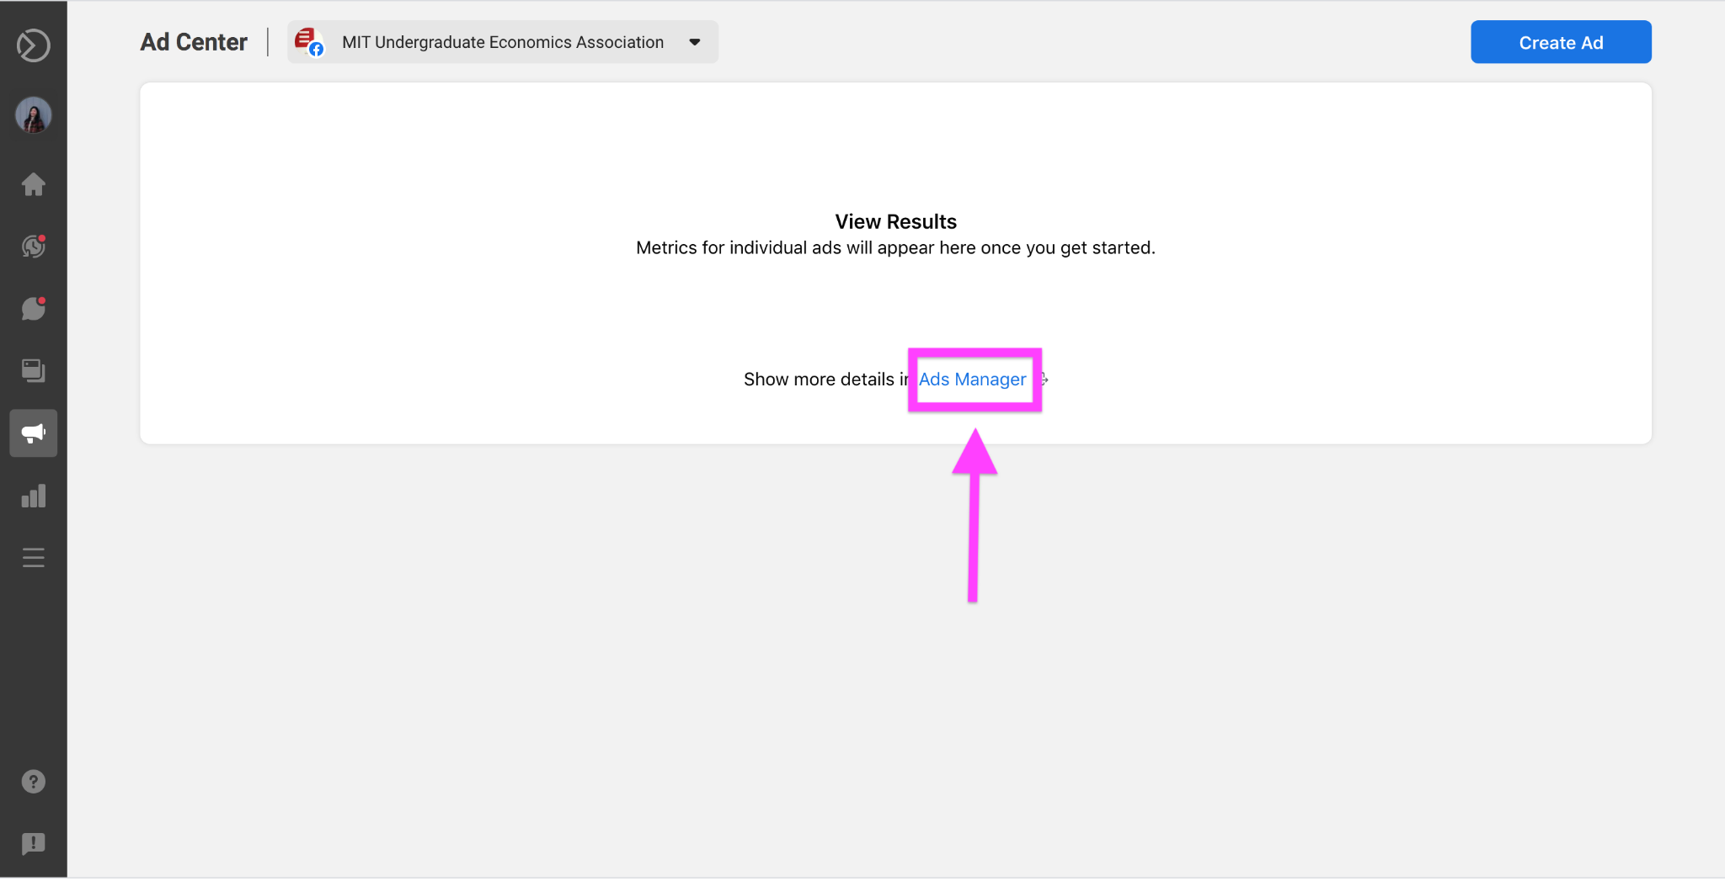

Step 4: Within Ads Manager, click the green “Create” button.
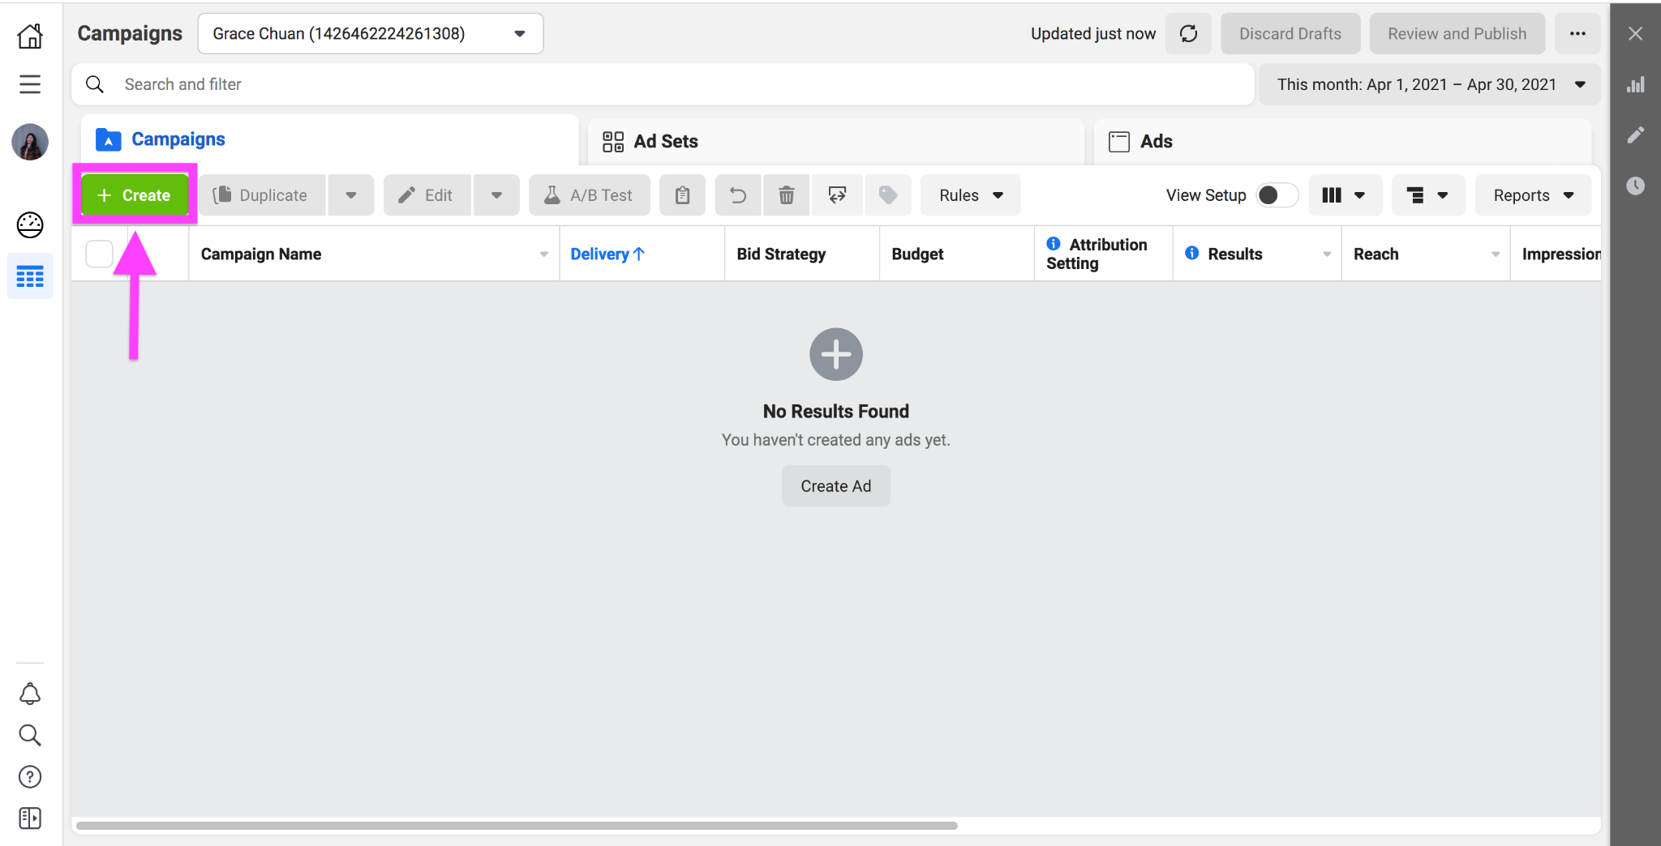

Step 5: You will need to choose a campaign objective from one of three broad categories: Awareness, Consideration, and Conversion.
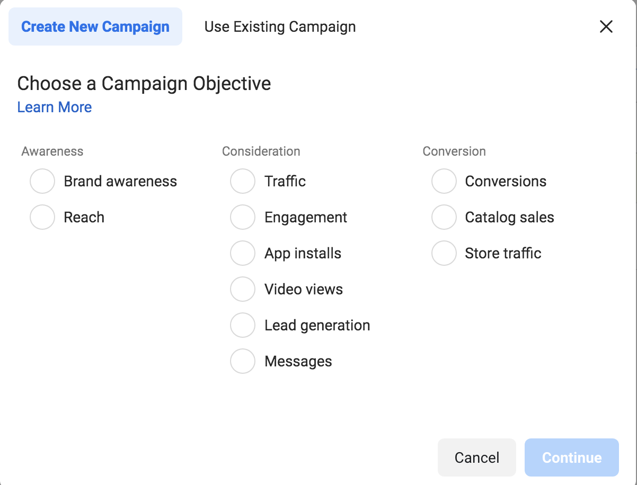
- Q1: What differentiates these three categories?
- Q2: In what situations would you select each category over the others?
- Q3: Under “Awareness”, there are two objectives: “Brand awareness” and “Reach.” How might these two objectives target audiences differently?

Step 6: Select “Brand awareness” as your campaign objective.

Step 7: Name your campaign!
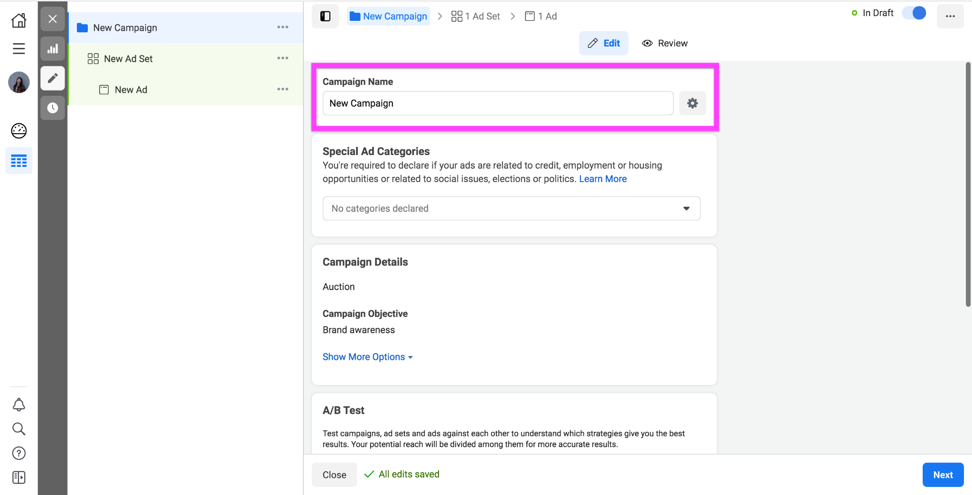

Step 8: Scroll through the special ad categories. You will see four different options.
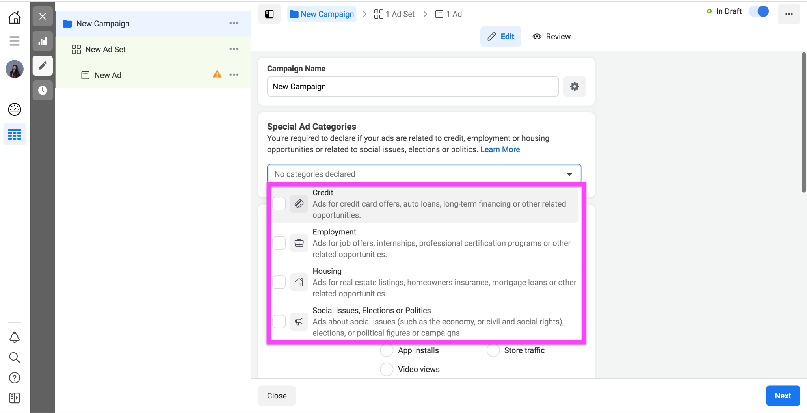

- Q4: What is the purpose of selecting a special ad category, and why might Facebook ask advertisers to do so if they have an ad that falls under one of these four categories?
- Q5: Choose two of the four categories, and provide real-world examples of how running an ad within each of them might lead to unintended social impacts.
- Q6: For ads that fall under the first three categories listed, some targeting features are disabled, such as “Look-Alike audiences,” which allows the user to target audiences by age, gender, ZIP code, or other demographic identifiers. Why do you think Facebook made this a choice for these three categories specifically?
- Q7: In addition to Look-Alike audiences, there also exists a “Special Ad Audience” feature that determines an audience based on similarities in online behavior and activity. Do you think this is a better alternative to a Look-Alike audience from an advertising and/or ethical standpoint? Why or why not?
- Q8: Refer to section “Database Ethics: Targeting from the Developer’s Perspective” in the case study. Based on Kant’s discussion of session-based recommendation vs. traditional identity profiling, what are the tradeoffs of an advertiser deciding to implement one over the other?

Excerpt from the WSJ, April 10, 2021:
“If Apple is King Kong and Facebook is Godzilla, mom-and-pop online merchants are worried they’re the screaming, scattering citizens who are about to get stomped as these two giants battle it out.

What’s at issue is a seemingly small change to the iPhone and iPad operating system that upends the past decade of the online ad industry, by prompting users to choose whether or not they’d like to be tracked by the apps they use.

Before, even the smallest business could throw as little as a hundred bucks at a tiny ad campaign on Facebook or Instagram, and get detailed and immediate feedback. Now they will have to spend substantially more—thousands of dollars at least—to show their ads to a larger audience, because the targeting will be less precise, says Christian Lovrecich, founder of PixlFeed Media, an e-commerce marketing agency.

Much of this targeting is driven by Facebook’s “look-alike audiences” feature, a complicated algorithm that uses artificial intelligence to generate a pool of people who resemble, in ways that affect how they’re likely to spend, an existing pool of customers or prospects provided by a merchant. For example, a merchant that already has a mailing list of customers for its adult onesies can feed that to Facebook, and Facebook’s algorithm will allow them to find yet more fully grown humans who are likely to wear children’s pajamas. These could be obvious similarities, like age, and not so obvious, such as having a job in an industry that allows working from home. The more data Facebook can feed this algorithm, the more correlations it can look for.

This situation highlights a fundamental trade-off between two countervailing trends in technology as a whole: consumers’ desire for privacy and their desire for experiences tailored just to them...” Read the full story here.

Step 9: Click “Next” to reach the next page, “New Ad Set.”
- An ad set is a specific ad you are designing for an ad campaign; therefore, one campaign can run multiple ad sets. Ad sets can target different audiences and be scheduled to appear on feeds at different times.

Step 10: Name your ad set!
Step 11: Click “Learn More” in the “Dynamic Creative” section, and read the article provided.
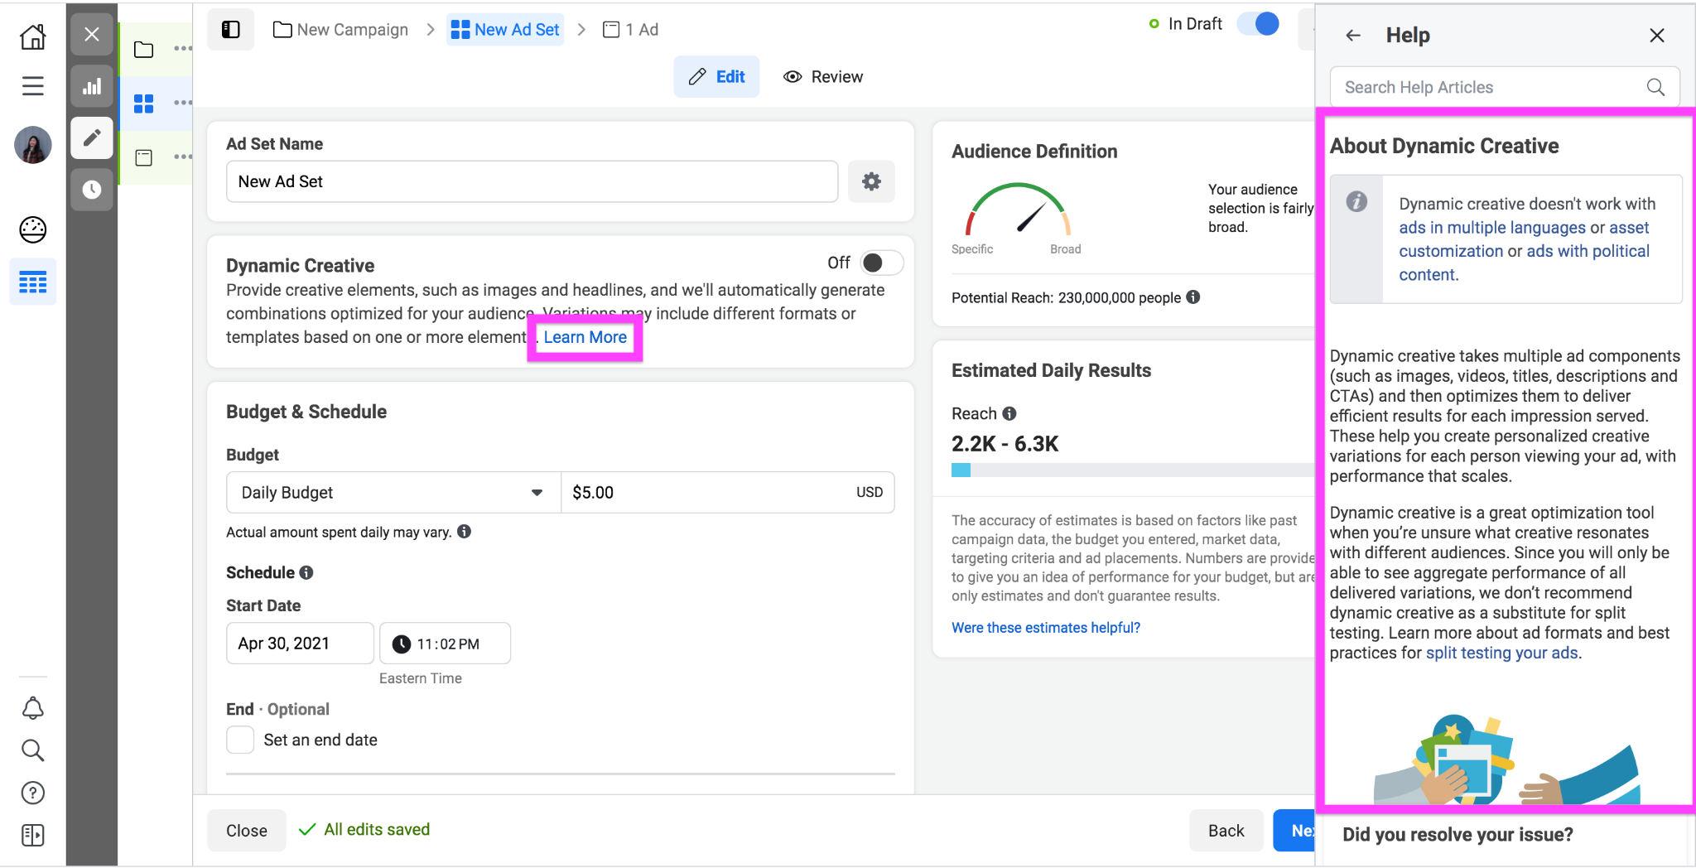
- Q9: The dynamic creative feature is still a form of targeting, but is less explicitly focused on identifying features such as race or gender. What are some possible drawbacks or limitations to this approach?

Step 12: Within the “Audience” section, select “Create New → Lookalike Audience.”
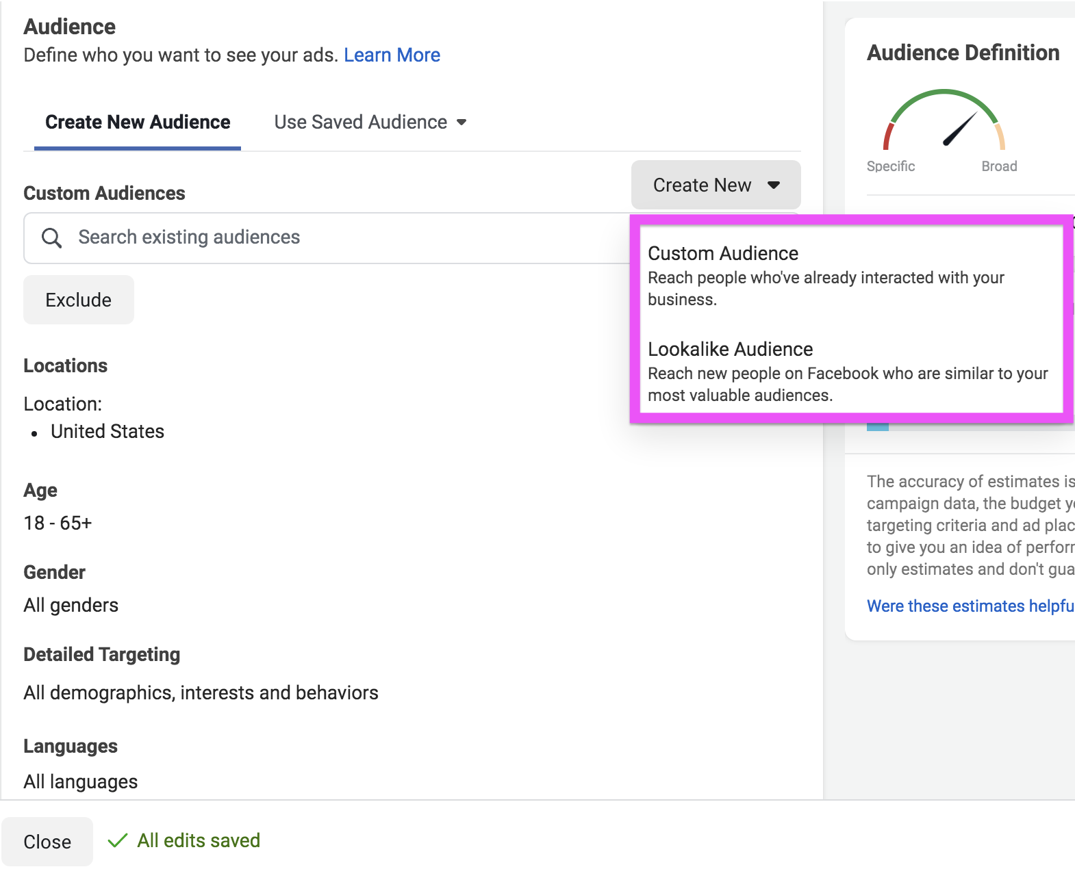

Step 13: Click on “Create New Source → Custom Audience with LTV.” A custom audience allows Facebook to construct an audience for your ad based on the customer dataset you provide and your choices about which features to optimize for. This audience will be composed of individuals outside your own customer list.
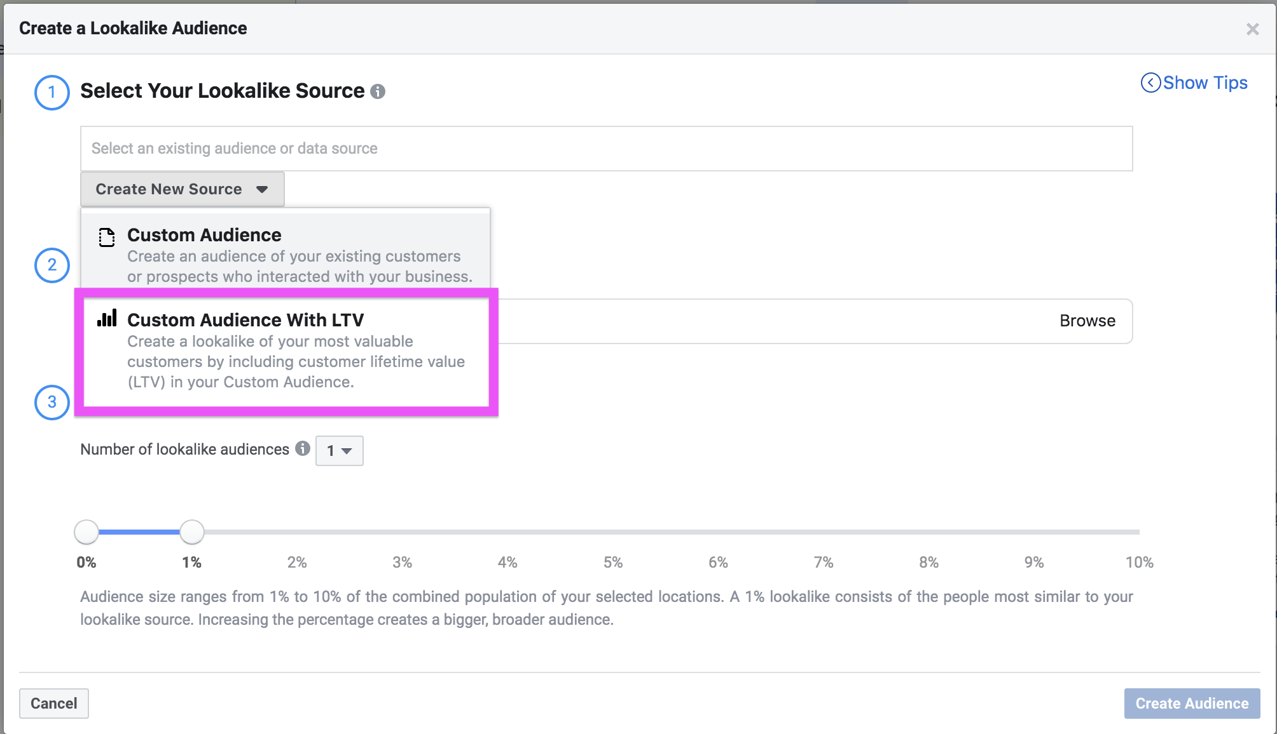

Step 14: Upload the provided .csv as your customer list.
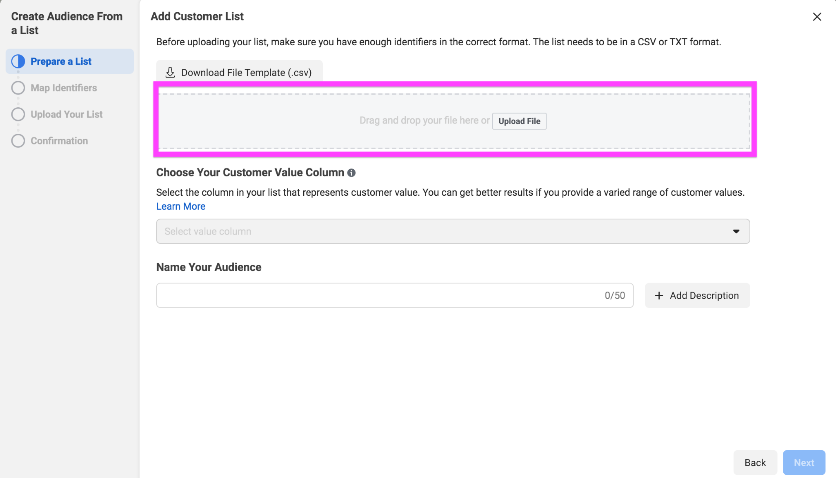
- Q10: What are the ethical implications of businesses being able to target audiences who resemble individuals described in this customer list by the features included?

The key feature in this dataset is the “Customer Value” column. The customer value is a numeric representation of the net profit you predict will be attributable to a given customer over the duration of your relationship with them. The Lookalike Audience feature will target more people who are similar to the individuals with the highest customer values.

- Q11: What are three different ways of potentially measuring customer value, and the ethical implications of each?

Step 15: Select the “Customer Value” column and name the customer list to move on to the next page.

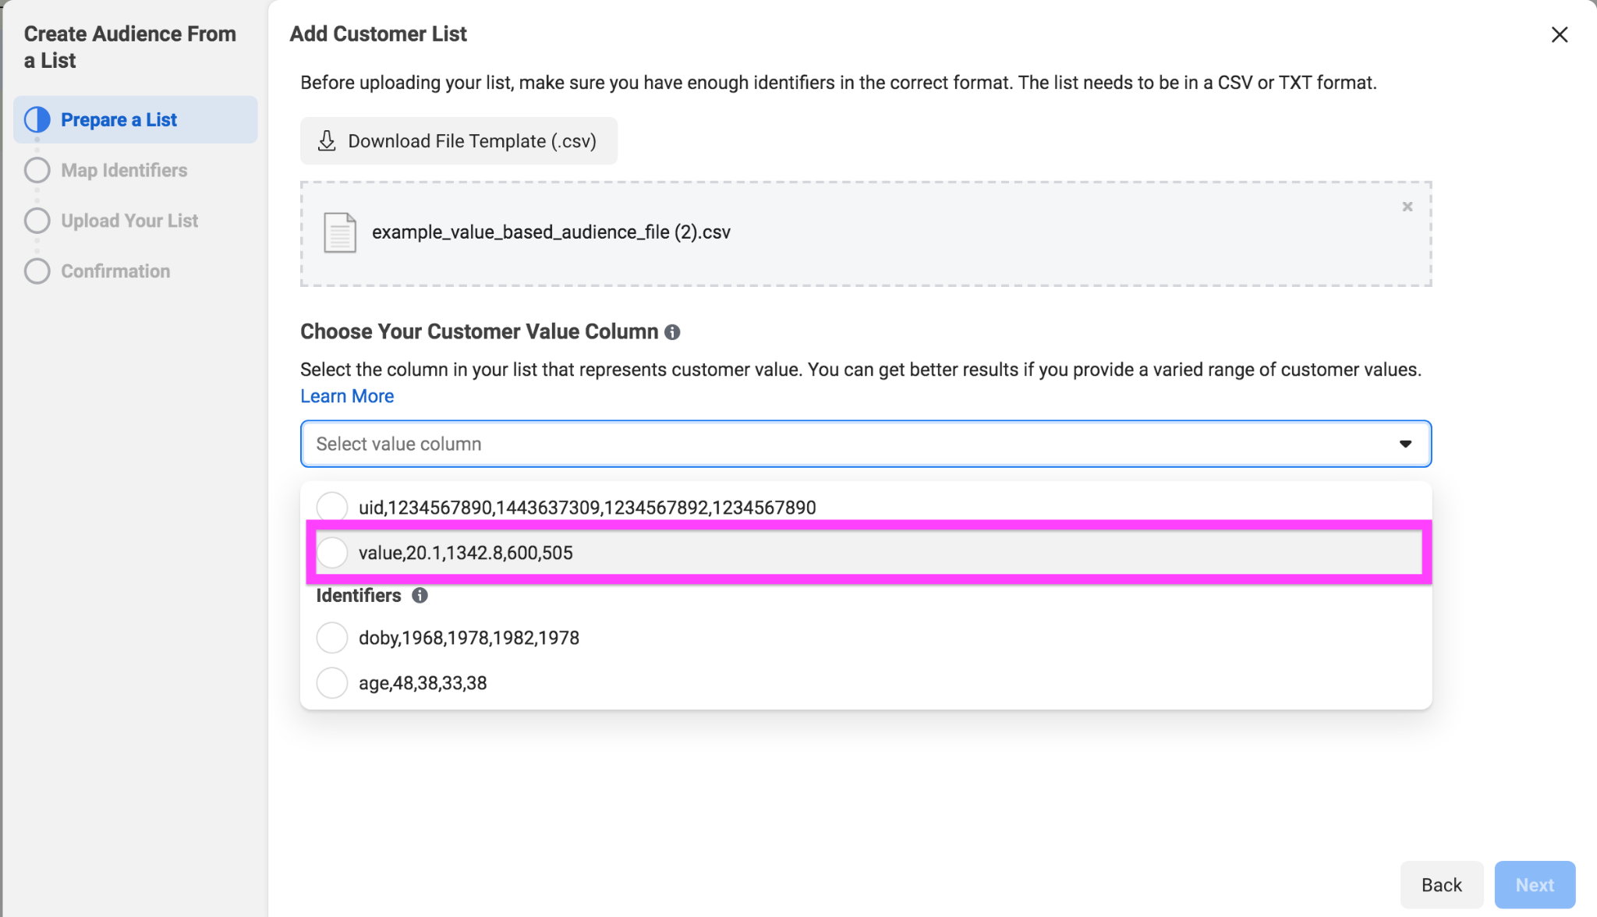

Step 16: After clicking “Next,” be sure to assign the correct identifiers to each column of the dataset.
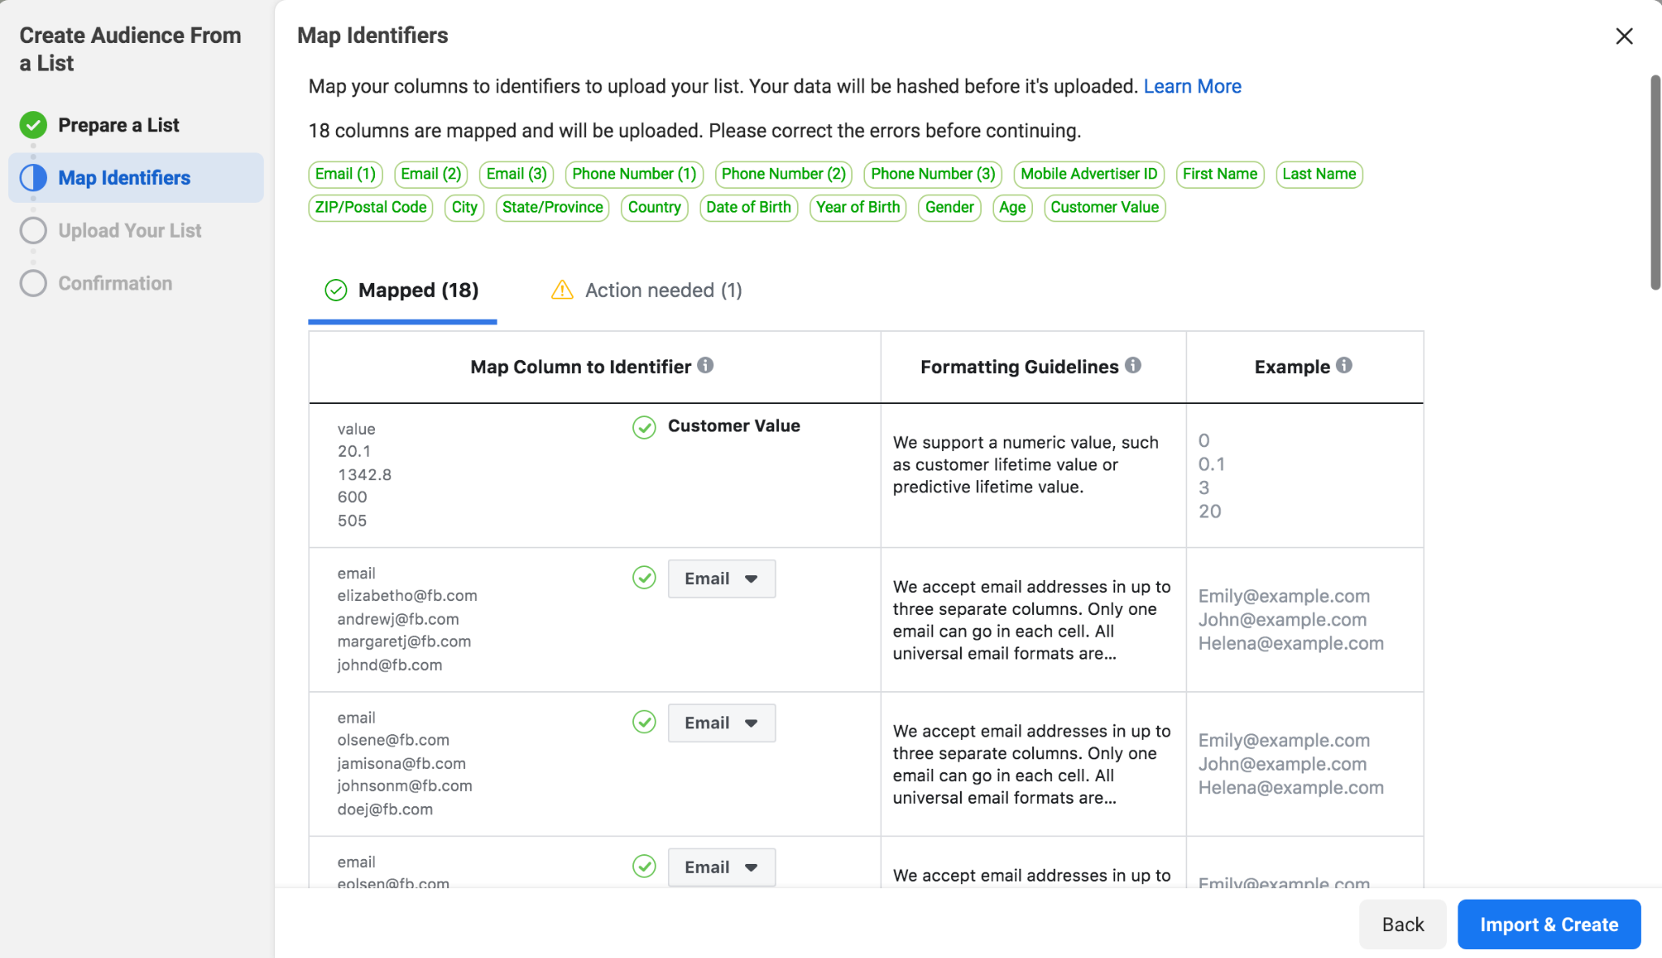

Step 17: Upload the list. Facebook is now hashing the data.
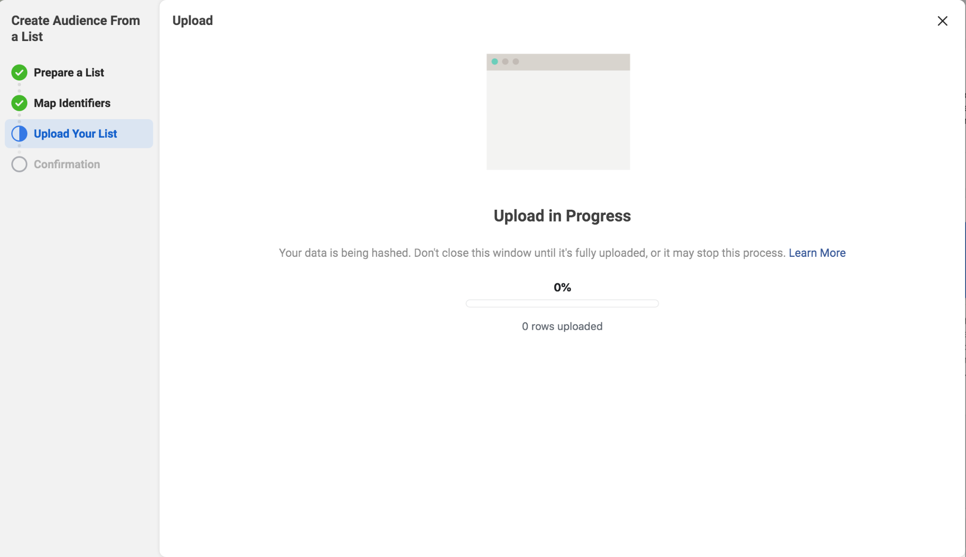
When you upload your customer list in Ads Manager to create a Custom Audience, the information in your list is hashed before it’s sent to Facebook. Hashing is the application of cryptographic primitives to map data to representative numerical values. Facebook’s hash functions are one-way functions: you cannot recover the original data from the hashed data.

Facebook uses this hashed information and compares it to the company’s own hashed information. Then, Facebook builds your audience by finding the Facebook profiles that match the specified criteria, and creates a Custom Audience from those matches. After your Custom Audience is created, the matched and unmatched hashed information is deleted.

- Q12: How does hashing individuals’ data and then deleting it potentially preserve (or not preserve) people’s privacy? Do you think hashing makes a difference in ameliorating the negative implications of targeting? Why or why not?

Step 18: Complete the process of selecting your lookalike source.

Step 19: Select an audience location based on where you think your ad would be most impactful given your business description.

Step 20: Select an audience size — the larger the percentage, the broader the audience.
- Q13: What are the equity implications of selecting a broader or narrower audience?
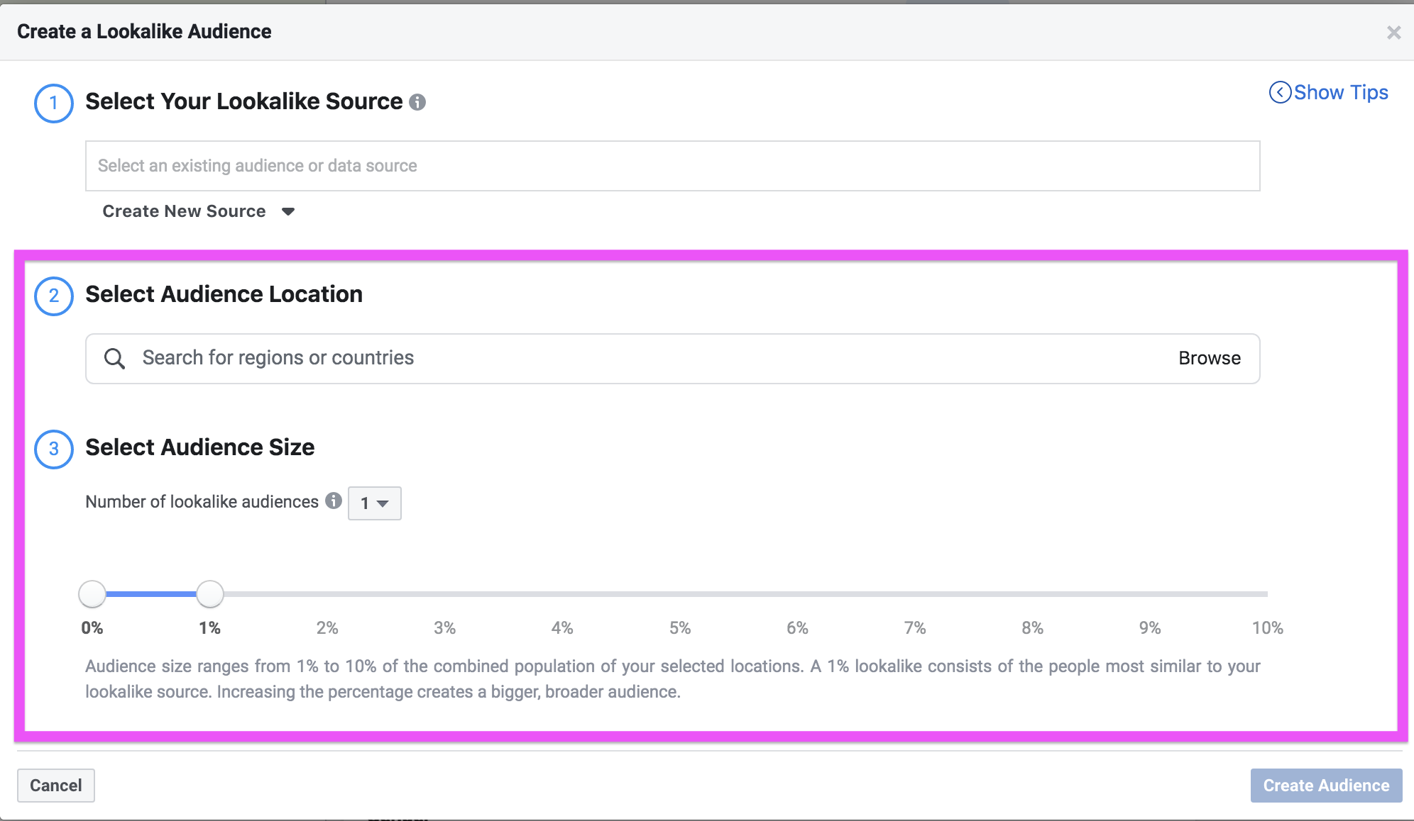
Step 21: Finish creating your audience and exit the window.

Step 22: Adjust age and gender group.
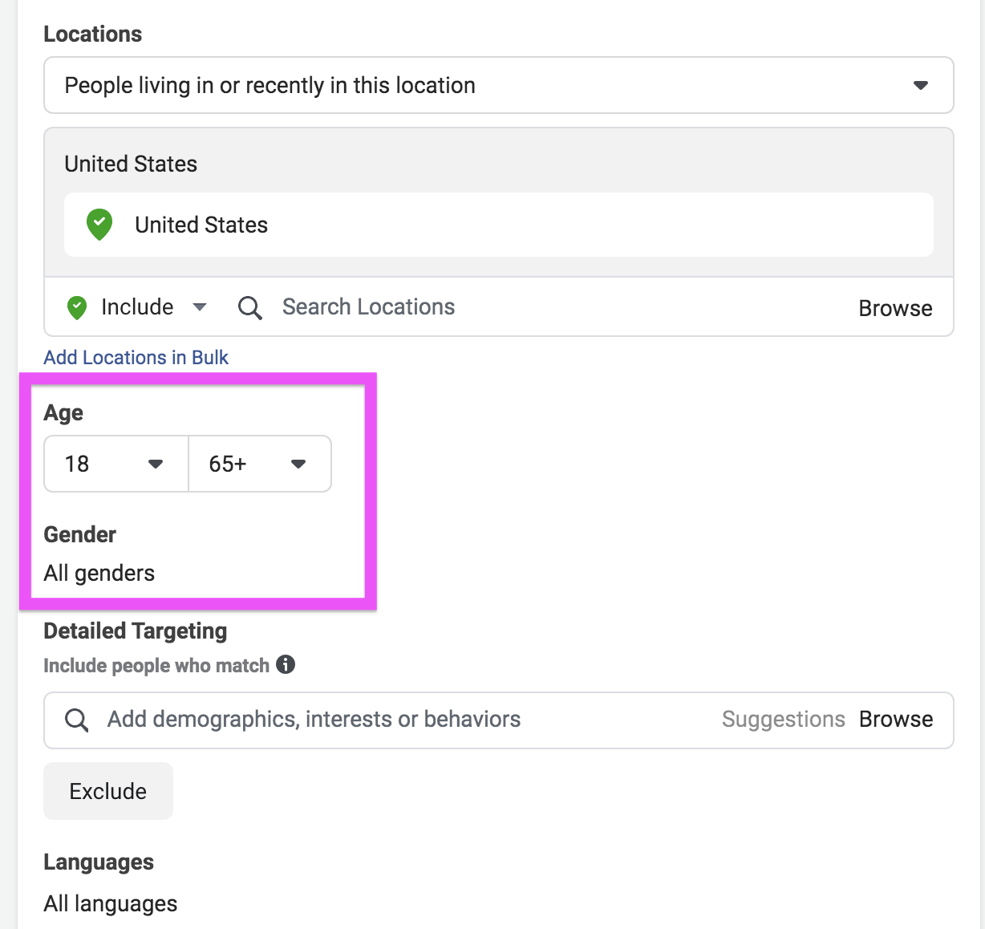

Step 23: Open “Detailed Targeting.”
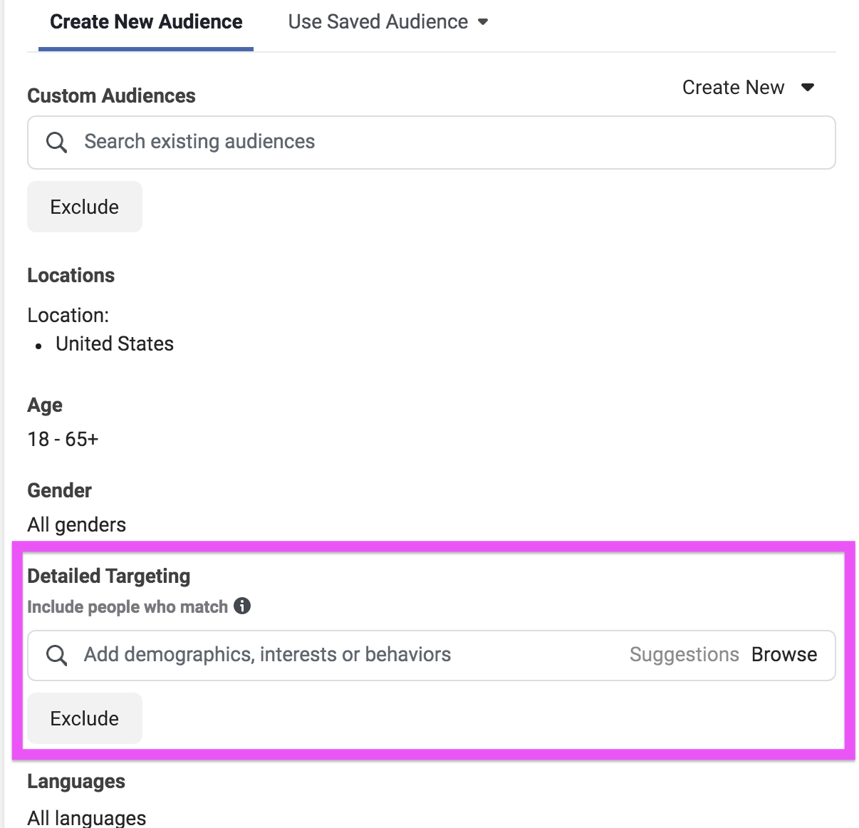

This feature includes and/or excludes certain audiences into tiers. For example, you could add vegetarians to "Include/Exclude," and people who are interested in gardening to "Narrow Audience." Doing so would result in the following setup:
  - Include/Exclude: Frequent travelers or vegetarians
  - Narrow Audience: People interested in cooking or gardening
  - Narrow Further: College grads
  - One criterion from each tier must be met for inclusion/exclusion; for example, a vegetarian college graduate who is interested in gardening would be in the audience, but a frequent traveler interested in cooking who isn't a college graduate would not be.
- Q14: How do you think the ethics of Detailed Targeting compare to the other targeting methods we’ve seen so far?

Step 24: Save your ads, but do not hit publish!

Done!

Discussion questions:
- What was your most surprising finding while performing the lab? How did the ad-targeting system compare to what you expected?
- Do you feel differently about the ethics of targeted advertising depending upon the type of ad being run (e.g., fashion, politics, housing)? If so, how and why?
- What benefits or drawbacks do you observe to Facebook’s advertising model, for Facebook and/or society?
- Is there a need for the government to intervene? If so, what role should the government play? And if not, why not?
- What are the responsibilities of employees within an organization that commits ethical violations?

Facebook screenshots © Facebook. All rights reserved. This content is excluded from our Creative Commons license. For more information, see https://ocw.mit.edu/help/faq-fair-use/

Wall Street Journal article excerpt © Wall Street Journal/Dow Jones & Company Inc. All rights reserved. This content is excluded from our Creative Commons license. For more information, see https://ocw.mit.edu/help/faq-fair-use/

MIT OpenCourseWare
https://ocw.mit.edu

RES.TLL-008 Social and Ethical Responsibilities of Computing (SERC)
Fall 2021

For information about citing these materials or our Terms of Use, visit: https://ocw.mit.edu/terms

